2.80: If the speed of the flowerpot at the top of the window is v₀, height h of the
window is

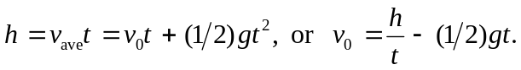

The distance l from the roof to the top of the window is then
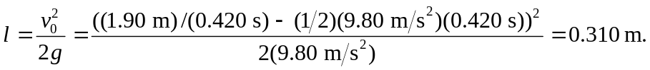

An alternative but more complicated algebraic method is to note that t is the difference between the times taken to fall the heights l + h and h, so that

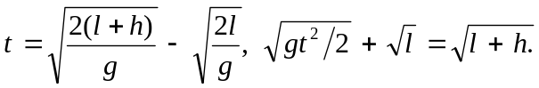

Squaring the second expression allows cancelation of the l terms,

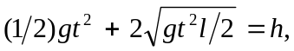

which is solved for

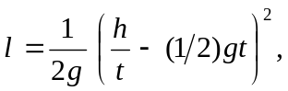
which is the same as the previous expression.

